Dear Parent of Students in Year 11 and Year 13

As a Trust we would like to record our support and appreciation for the work done by Secondary Schools within Our Lady Immaculate Catholic Academy Trust. As the confidential work of the schools in allocating grades has now finished we are left with the next stage in the allocation of these grades to our students which is in the hands of OFQUAL (The Office of Qualifications and Examination Regulators).

At this stage the Trust and our Secondary Schools, Thomas Becket Catholic School in Northampton and St Thomas More Catholic School in Bedford have to surrender any further influence on the grading process.

The next stage is that statistical moderation will take place. Part of this process may include historical data pertaining to the schools and to the cohort (Group of children within the school sitting exams at this time.).

This data used to moderate could take the form of KS2 SATS and former examination results of the schools and National examination results. Thus although teacher judgement was used initially to allocate grades the next steps are subject to moderation and possible changes by OFQUAL. Our expectation is that that this will be a just and fair process which reflects the annual process of moderation of grades done by the exam boards.

As a Trust we would like to fully endorse the work of the schools in their part of this process. We have carefully scrutinised the steps that have been taken. We have full confidence in the integrity of staff and the careful checking that has gone on right from the beginning of the process.

We look forward to the receipt of these results for each individual child. Their efforts deserve recognition and celebration.

Yours sincerely,
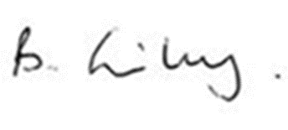
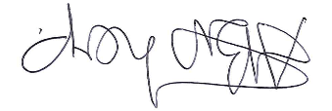

Tony Bishop Bernadette Grimley
Strategic Executive Lead Director of Teaching School

